1. **Subject : -**

Sentiment analysis using TextBlob.

* **Dataset Description : -**

1. Dataset link : -

* https://drive.google.com/file/d/1776tbm2dHXvPzBWdB1FPFHwteiovMNun/view?usp=sharing

1. Shape of the dataset : -

* Shape of the DEPRESSION dataset is :- (10314, 3).

1. Dataset (first five rows) : -

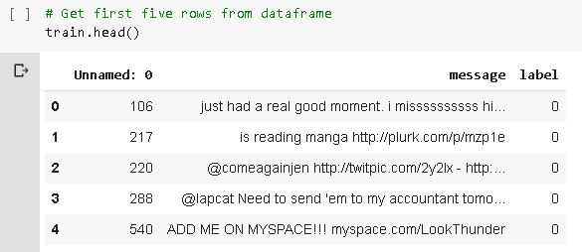

1. Data-Preprocessing : -

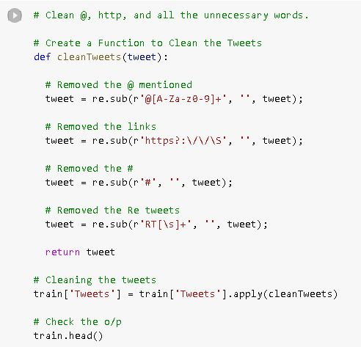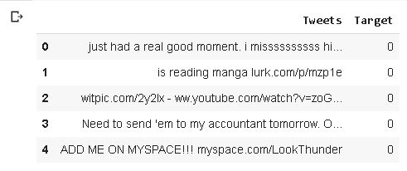

1. Dataset Description : -

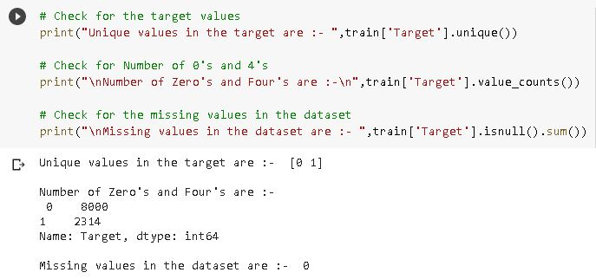

1. WordCloud Analysis of Positive words : -

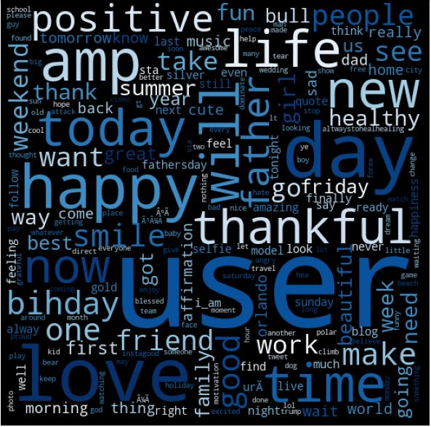

1. WordCloud Analysis of Negative Words : -

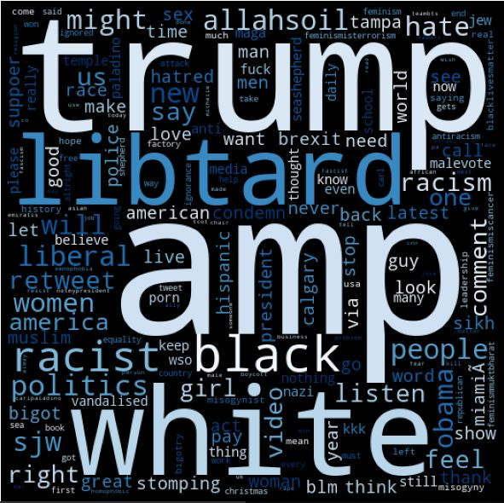

* **Description : -**

1. TextBlob uses a built in algorithm for sentiment analysis.
2. TextBlob predicts the Polarity and Subjectivity of the sentence.
3. Polarity determines whether the statement is Negative or Neutral or Positive.
   1. Polarity range from [-1,1]
   2. For Positive statement :- Polarity > 0 && Polarity <= 1.
   3. For Negative statement :- Polarity < 0 && Polarity >= -1.
   4. For Neutral statement :- Polarity == 0.
4. We can directly calculate the Polarity of the sentence using TextBlob(Tweet).sentiment.polarity
5. Subjectivity determines whether the tweet is related to personal or with emotions or related to factual information.
   1. Subjectivity Range is [0,1]
   2. If subjectivity is higher then the tweet mostly refers to it is related to public opinion otherwise it is factual information.
6. We can directly calculate the Subjectivity of the sentence using TextBlob(Tweet).sentiment.subjectivity.
7. To calculate the accuracy for Textblob, we first calculate polarity and subjectivity. And if polarity >= 0 we consider it as a positive sentence.
8. And if polarity < 0 then we consider that sentence as a negative sentence.

* **Accuracy of Algorithm : -**

Precision: 42.15%

Recall: 100%

F-score: 59.31%

Accuracy: 91.04%

* **Output of Test Result : -**

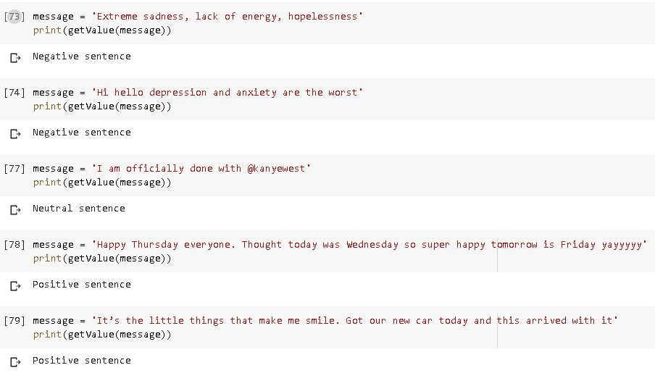

* **Advantages of the TextBlob: -**

1. Accuracy of the algorithm is quite impressive.
2. TextBlob even predicts the subjectiveness of the sentence.

* **Code Link : -**

1. We used “Google colaboratory” to execute the code.
2. Link of the code : - https://colab.research.google.com/drive/1IYBqCVlEKTsaPQS0S9u_9YlDbNQcGUOB?usp=sharing